**Student Information**

Name: PrajwalAradhya Shivakumaraswamy Kesaramadu

Banner ID: B01759301

Name: Aman Misra

Banner ID: B01746656

Name: Sreeraj Karuvanthodi Ramachandran

Banner ID: B01764963

Date: 08-11-2024

Course: Enterprise Architecture

**Class Exercise 5**

Create the High-Level Business Process Model using UML Activity Diagram with horizontal swim-lanes for the Coursework Submission and Assessment System (CSAS) described in the Case Study. You can use draw.io or any other tool you prefer to draw it. Then, submit your solution as a single Word file to Class Exercise 5 submission point on AULA. Your solution must include the diagrams of the following business processes:

1.Module Coordinator: Add Coursework Assignment

2.Student: Submit Coursework

3.Module Coordinator: Send Marks to Banner.

1. **Module Coordinator: Add Coursework Assignment**

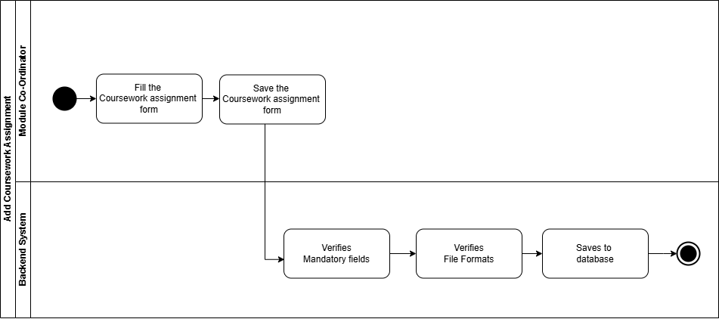

1. **Student: Submit Coursework**

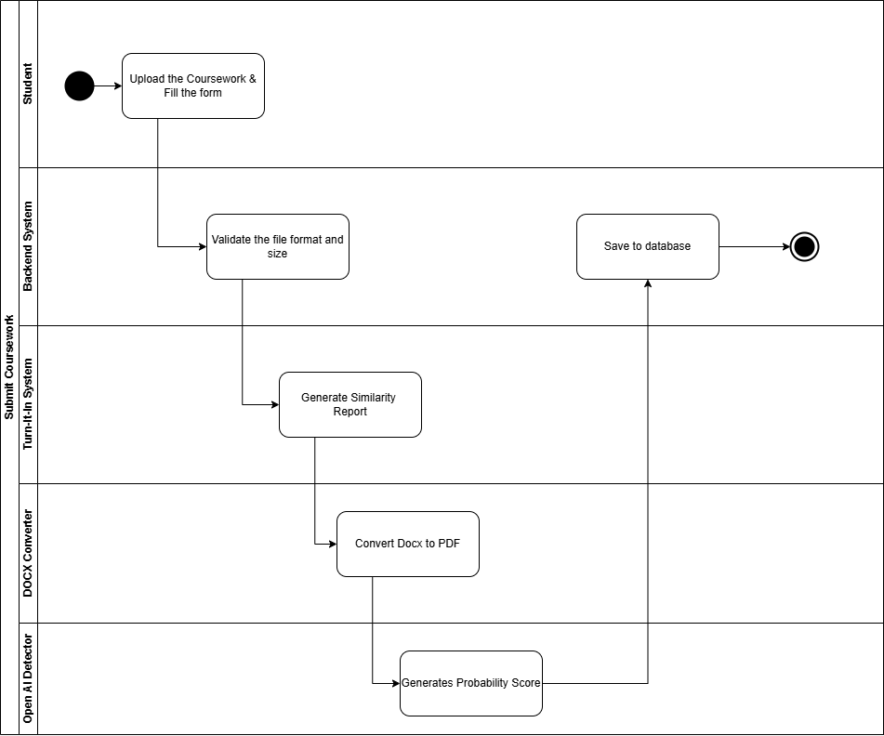

1. **Module Coordinator: Send Marks to Banner.**

